Please answer the following questions and email them back to me at Kristen@kristenadamson.com. I understand that there are several questions below, however, it is imperative that you take the time to answer them, as they will help me design the most ideal, safe and customized program for you and your body-type.

Age:  Weight:  Height:  Chest Measurement:  Waist Measurement:  Hip Measurement:  Right Thigh Measurement:  Left Thigh Measurement: | 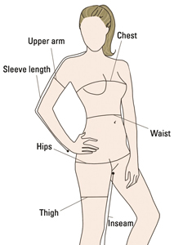

- What would you like to achieve by the end of your program? Be specific.

- How many meals do you eat a day, currently? (Including snacks)

- What is your typical schedule like? (Include work, school, gym etc.)

- If applicable, how many days a week do you currently exercise? Please also specify the type of training. (Cardio, weights etc.)

- Do you currently have or have a history of eating disorder? If so, please specify.

- Do you currently have or have a history of endocrine/hormonal disorder? If so, please specify.

- Do you currently have or have a history of any other medical issues (diabetes, heart issues etc.)? If so, please specify.

- What is your body–type? Please complete this online questionnaire to find out: (http://www.bodybuilding.com/fun/becker3.htm)

- Please take this questionnaire and provide your results. (http://www.kristenadamson.com/quiz.html) NOTE: your result will simply notify me of your current mentality.

- Do you have any known food allergies?

- Are you currently taking any medication? If so, please specify.

- Are you currently taking any supplements? If so, please specify.

- How many bowel movements are you experiencing a day? (average)

- What sort of workout equipment do you have access to at home (if any)?

- Are there any foods you simply will not eat?

- Please include an example of a typical days food intake. If desired (and for more accuracy) you may also wish to food journal for 1-3 days and include the specifics below.

